DATA 320 Module 3 Data Visualization Using PowerBI

Overview
For this assignment, you will:

- Create at least five visualizations in Power BI using industry-standard techniques
- Use the Q&A feature in PowerBI to create three additional visualizations
- Discuss the impact and purpose of each data visualization
- Build a dashboard to convey a story about the data
- Publish your work to Power BI Service
- Export your report from Power BI into a PowerPoint
- Create a PowerPoint presentation that explains each of the eight visualizations, the two dashboard panels, and recommendations for next steps.

Scenario
The data exploratory analysis and preparation that you performed for the ACME Pharmaceutical company was very well received. The HR Data Entry team was able to identify the missing data and have provided it to you now. They also added a field: Date Performance Appraisal which is the date of the employee’s performance appraisal so that you can look for any trends related to time.
You will load your data in PowerBI desktop, then you should go into the data transformation to ensure that you don’t have missing values, outliers, or abnormal data. After you are satisfied with your data, you can return to PowerBI.

Exploratory Visualization Phase
Go back to your Professional Memo and refresh yourself:
What are you trying to understand and accomplish?
What were the trends that you found using the Key Influencer Visualizations?
What is the nature of the fields in the data: categorical versus continuous?
The answers to these questions will guide you as you build at least these five types of visualizations and a brief and general statement about the industry-standard best practices. You should refer to the required reading in the Module 3 chapter for in-depth guidance.
- Bar Chart- the count of values in categories.
- Line Graph- data over a time span.
- Pie Chart- categorical data that is part of a whole (for 5 or less categories).
- Scatter Plot- relationship between two continuous (numerical) variables.
- TreeMap- categorical data that might be sliced in more than one way. Also used when you have more than 5 categories.
For each of these visualizations, create a new page (report) in PowerBI. You will need to practice, refine, and adjust these so give yourself enough time to play around and experiment. Feel free to add more advanced features that you have seen in the reading materials. You should rename each page to something meaningful instead of “Page1” to help you remember what is on each page/report.
Special note about aggregations: By default, when you click and drag a continuous variable like age or distance from home into one of the visualization- the default aggregation method is SUM. However, this does NOT make sense for many of the fields that you will be examining. So, you will need to change them from sum to average OR don’t summarize. To do this, you will need to click on the down arrow to the right of the field in the visualizations area. This is a very important step in learning how to properly perform data analytics and you need to be sure that you are thoroughly thinking about what you are calculating.
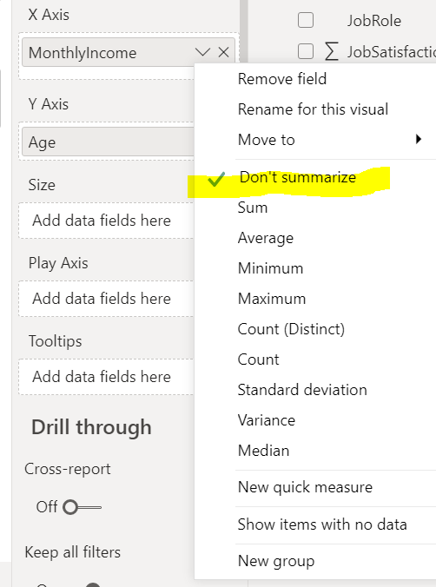
Create a new page called “Q&A”. Drag the visualization “Q&A” over to the report 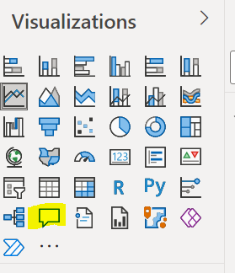
You can either ask a question such as “what is the average age?” or you can look at their suggested questions. Just keep in mind that they might ask a question like, “what is the total age?” which doesn’t make any sense. The system doesn’t understand “what” the meaning of the fields are, it is just trying to build in questions that might be helpful.
Once you find an interesting visualization created by the Q&A feature, click on the icon to the right of the question box. This will convert it into a visualization. 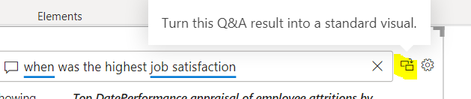
Now, take the box created by the visualization and pinch/change it so that it takes up a third the space on the page. Then add another Q&A visualization, ask another question and create a visualization. Repeat this one more time.
You should now have three visualizations that resulted from the Q&A feature.

Storytelling Phase
You are going to be creating two dashboard panels for this exercise. You will be selecting which visualizations to include on each panel based on the best way to tell a story about the data. For example, maybe you want to focus on one aspect of the employees, like age, department, education, etc. So, you will pick the visualizations that might best highlight the findings about employees that leave/stay.
You will create two new pages-named Dashboard Panel 1 and Dashboard Panel 2.
Then you will go into each of your eight visualizations that you created, right click on the visualization, and select “copy visual”. Then immediately, go to the appropriate Dashboard Panel and click the CTRL button and V to paste (there is no right-click- paste). This should create a duplicate of the visualization onto the dashboard page. Now, you need to shrink it by using your mouse to grab the corners and make it smaller. Repeat this for the other visualizations that you want grouped on that dashboard page. Then do those steps for the other dashboard page. So, you should have at least four visualizations on each dashboard panel, all that can relate to each other in some way.
Add at least one text box to each dashboard page that contains a brief statement about the dashboard. What do you want your reader to look at or notice?

Publishing to Power BI Service
In order to use some of the other Power BI tools that are only available in the Power BI Service, you need to Publish to Power BI. Once you are satisfied with your two dashboard panels you created in the step above, click on the “Publish” icon in the toolbar.
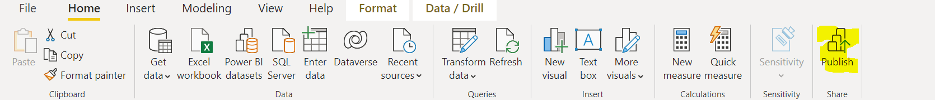
First, you will be prompted to save your Power BI Desktop workbook, do this to a location and make note of that location. *if you are using the Virtual Lab (VDA) to access Power BI desktop, follow the instructions- Loading files and Publishing Power BI in the UMGC Virtual Lab found in the classroom.
Next, click on “My workspace” and Select.
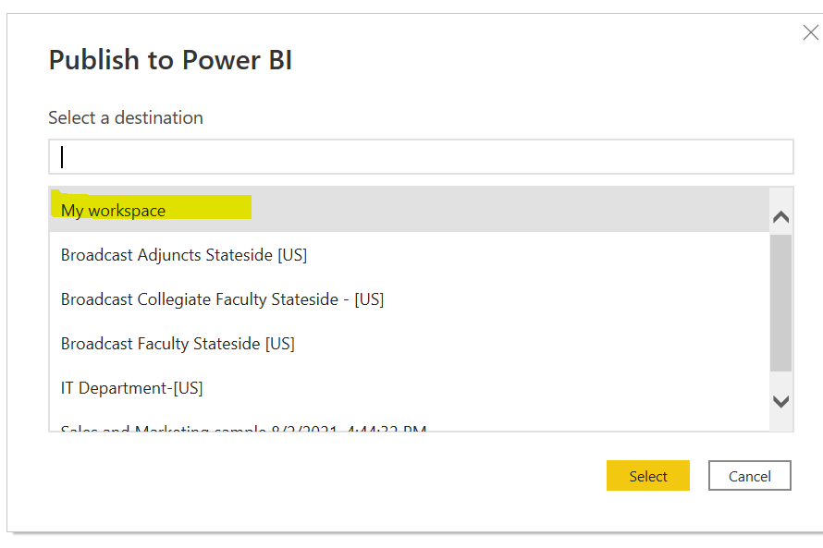
After it finishes, click on the link to Open your dashboard in Power BI Service. You might need to sign into your Power BI Service account.

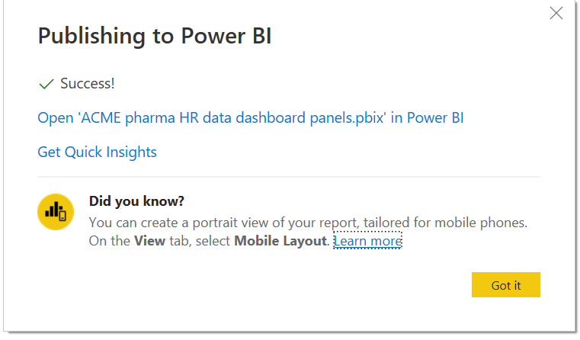
Once you are in Power BI Service, click on “Export” and PowerPoint.
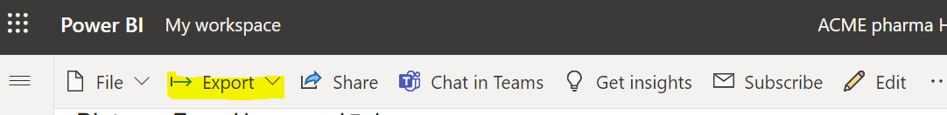
Be sure to select “Current Values” so that it exports ALL the pages you created into PowerPoint. This will download a PowerPoint file.
When you open the file, you will notice that the Power BI Service created a title slide and slides for each of the pages that you created.
You will be using this export to create a presentation for the company. You need to adjust the following slides:
- Title page:
  - Make sure the title is professional and helpful to your audience (for example, “ACME Pharmaceutical HR Visualization”).
  - Add a text box that includes your name and your professor’s name.
  - Make sure to leave the link for “View in Power BI”- your professor will click on this to view your dashboard.
  - You can leave the data refresh and downloaded dates at the bottom of the page.
  - You can change the color or background if you prefer.
- Visualization slides and explanations (8 at a minimum)
  - For each of the eight visualizations that you created (bar chart, line graph, pie chart, scatter plot, tree map, and three Q&A visualizations), you will need to explain what you did and why you chose it. If you included any additional visualization other than the eight above, please include and explain why you created them.
  - For each visualization slide, you MUST write your explanation and justification in the “Notes” section of the PowerPoint slide (bottom). This must be written in paragraph form as if someone was reading it verbatim for a presentation.
- Dashboard panels (2 at a minimum)
  - For each dashboard panel- explain in the notes section what common themes that you found in common with the items on the dashboard. Point the reader to the areas of the dashboard that you want them to investigate. Are there any questions that you believe arise from the dashboard? Include them for your viewer.
  - When your reader goes to your actual dashboard in Power BI- what should they click on to interact with your dashboard? For example, if you added department onto your dashboard, does something happen to other visualizations if they click on a particular department?
- Recommendations:
  - Add a NEW slide into your PowerPoint that provides at least 3-4 recommendations that you believe will help the company to keep their employees. These MUST be based on the facts that you presented in your visualizations and dashboard. What data-driven decisions can this company make with your information?

Consult the following resource for Best Practices for PowerPoint presentations. Be sure to adhere to these best practices when creating your presentation: https://alum.mit.edu/best-practices-powerpoint-presentations
In order to provide enough detail and not exceed the best practices for slide content, you will need to use the Speaker Notes function on each slide to add additional detail. 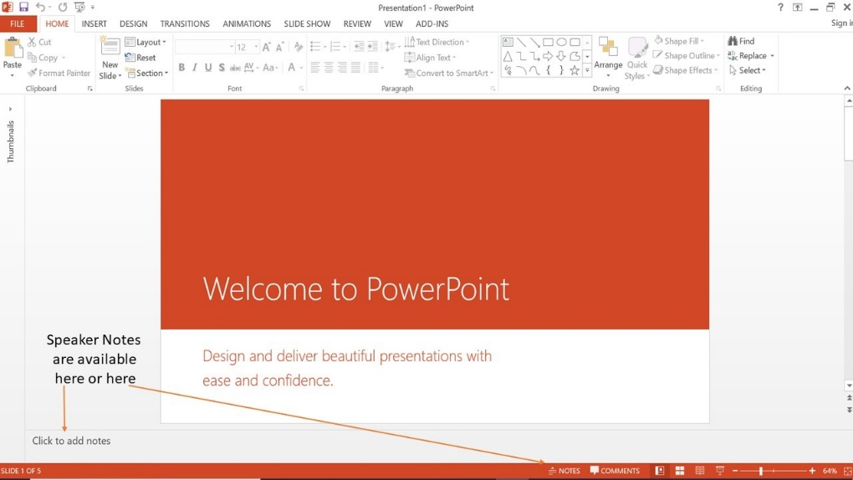

Final Instructions on Submitting Your Assignment
You will submit your PowerPoint in the Assignment in LEO to be graded.

Rubric Module 3 Data Visualization in Power BI
Item graded | Points | Exceeds | Meets | Does Not Meet
Title Page | 5 | The page contains all the required elements. | The page contains some of the required elements. | The page contains none of the required elements.
Visualization slides (minimum of 8) | 50 | The visualizations are designed to the best-practice standards and well explained. | Some of the visualizations do not use best-practice standards and/or explanations are missing. | There are no visualizations provided.
Dashboard | 20 | The dashboard explanations point out themes and provides the reader with ways to interact with the dashboards. | The dashboard lacks explanations of themes and/or do not tell the reader how to interact. | There are no dashboard explanations in the presentation.
Recommendations | 15 | The recommendations provided are based on the information presented in the visualization and/or dashboards. | The recommendations have some data-driven evidence, but it is not clear for all of them. | The recommendations are based on opinion only, not on the data that was presented in the visualizations.
Mechanics | 10 | The presentation is free of spelling and grammar errors. | The presentation has 2-3 spelling errors and/or 2-3 grammatical errors. | The presentation has too many spelling and grammar errors.

